Lab 5

1. A
   1. Explanatory: Mileage. Response: Price
   2. 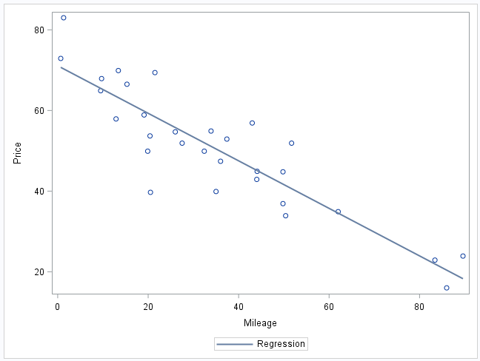
   3. Y is predicted price of the car and X is how fast the car value depreciates per mile
   4. Linearity, Constant Variance, Normality and Independence.
   5. 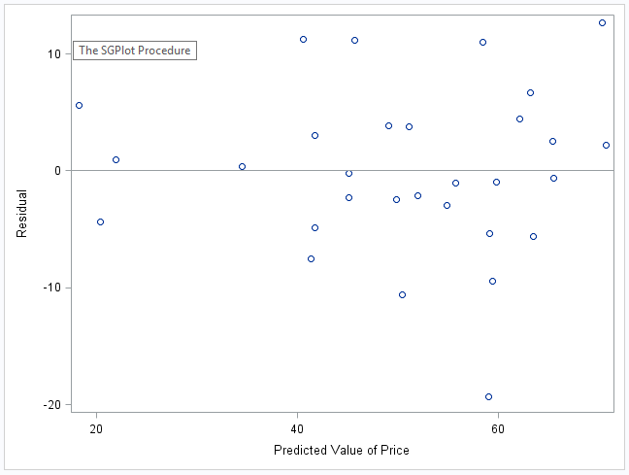
   6. In this case, Linearity is satisfied. Constant Variance is satisfied because there is a wide enough range in the points on the res vs pred graph.
   7. 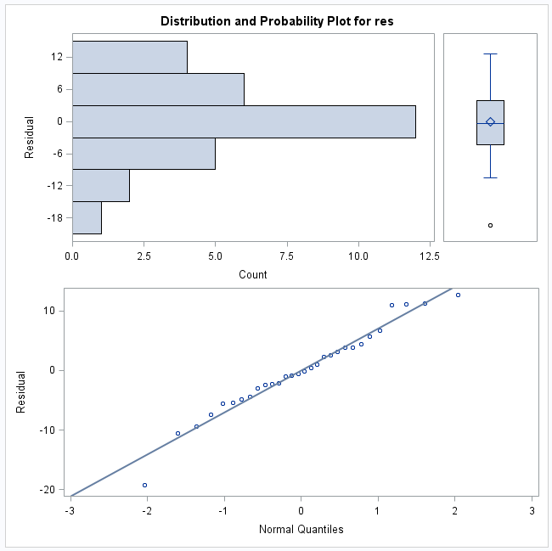
   8. Since the graph follows a bell curve and the points are staying very close to the residual line, this means it follows normality.
   9. Yhat = 71.09 – 0.59 * Mileage 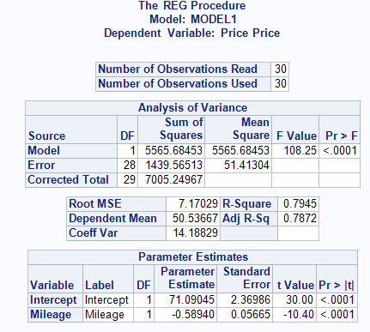
   10. This intercept means that with 0 miles on it, the car is estimated to be 71.09 (71,000)
   11. This slope means that for each 1,000 miles, the cost goes down about 590 dollars.
   12. Test Statistic = -10.40. This is calculated by doing -0.589/0.05665 (Parameter Estimate/Standard Error)
   13. P-value is < 0.0001
   14. At the 0.05 significance level, there is statistically significant evidence that the population slope of mileage is nonzero when price is in the model.
   15. 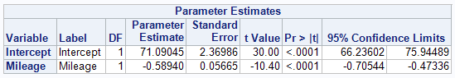 95% confidence interval for B1 is (-0.70, -0.47)
   16. We are 95% confident that the population mean price for all used 2007 Porsche cars decreases between 0.70 and 0.47 for every increase of 1 mile in mileage.
2. 1. 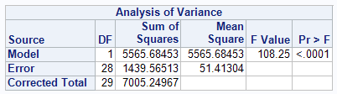
   2. Model is # of explanatory variables. Error is n – is # of explanatory variables – 1. Total is n – 1.
      1. 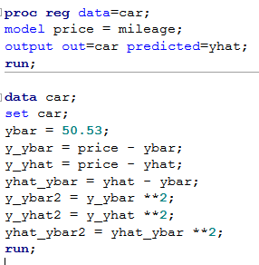
      2. 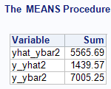
   3. Yhay_ybar2 is the Sum of Squares of the Model (SS(model)). Y_yhat2 is the Sum of Squares of the Error (SS(E)). Y_ybar2 is the corrected total (Sum of Squares of Model plus Sum of Squares of the Error)
   4. The F Value that is calculated gives the F statistic for the F test and is calculated doing the Sum of Squares of Model/(Sum of Squares of Error / Degrees of Freedom for the Error)) which comes out to 108.25.
   5. R-squared Value is 0.7945
   6. R Squared is calculated from SS(Model)/SS(Total)
   7. This measures the strength of the relationship between price and mileage
   8. 7.17
   9. This is the square root of the sum of error squares (standard deviation)
   10. The average distance from the actual price of car to the predicted prices is 7.17 thousand dollars.
   11. The Root MSE stands for the $σ$ in the $Y=β_{0}+β_{1}X+E,where E\sim N(0, σ)$ which is an estimate of the standard deviation of the errors
   12. We are 95% confident that the population mean price for all Porshe’s in 2007 with 40,000 miles on it is between 55.3 and 61.51 thousand.
   13. We are 95% confident that the price for an individual 2007 Porshe with 40,000 miles is between 43.4 and 73.4 thousand.
   14. This is because prediction intervals are harder to estimate the response value for an individual than the population mean
   15. R-squared = 0.745 and root MSE = 7.17 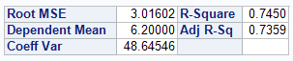
   16. The price and mileage relationship is stronger because the R-squared value is closer to 1. Since the R squared value measures the strength of the relationship, the higher the number, the strong the relationship is.